Image recognition with docker file:

Install docker desktop
Run below commands:

Open a terminal in the `Docker` folder:
Run command: docker build -t ai-image-classifier .

Run the container:
docker run -p 8501:8501 ai-image-classifier
You can now view your Streamlit app in your browser.
Local URL: http://localhost:8501

Other commands:
Run in background (detached mode):
- powershelldocker run -d -p 8501:8501 ai-image-classifier
See running containers:
- docker ps (to know contain id)
Stop a background container:
- docker stop <container_id>

Run docker file
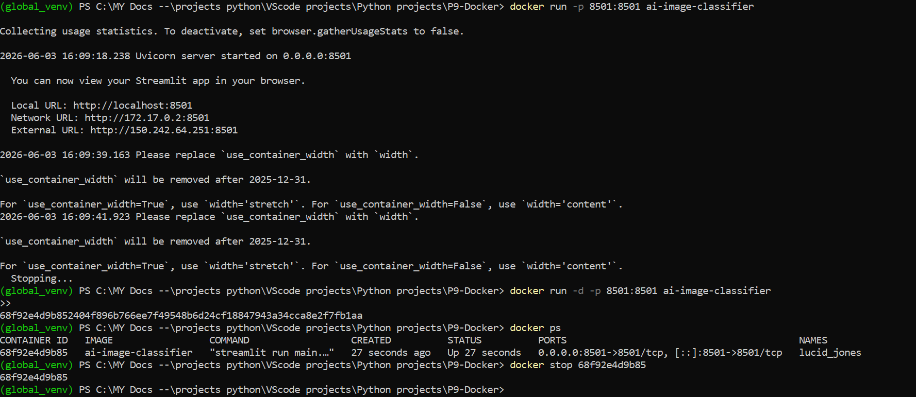

Webui for image classifier running with docker
Selected dog image
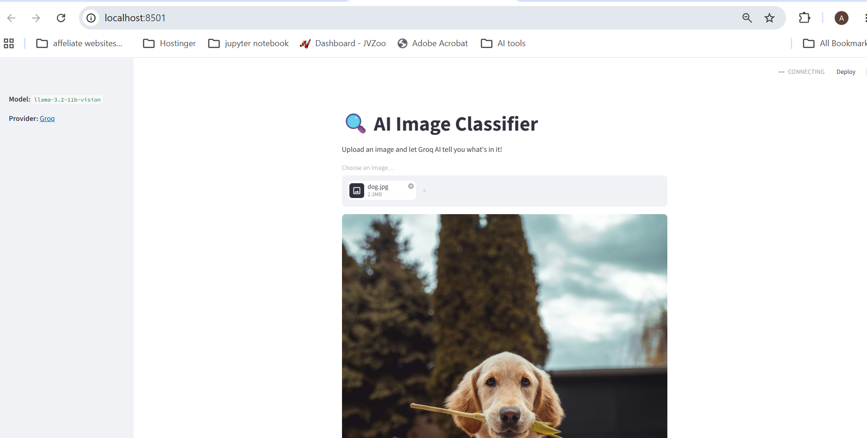

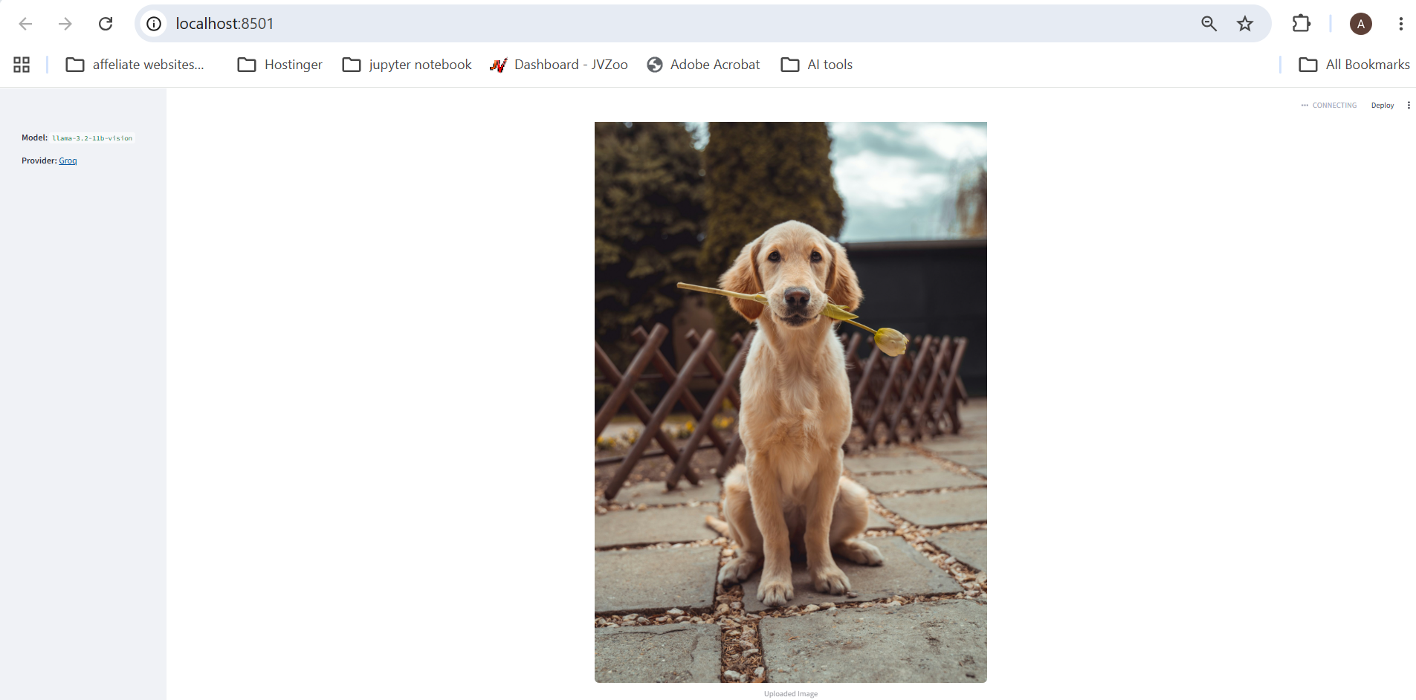
Dog image correctly classified using Grok LLm with dockerfile
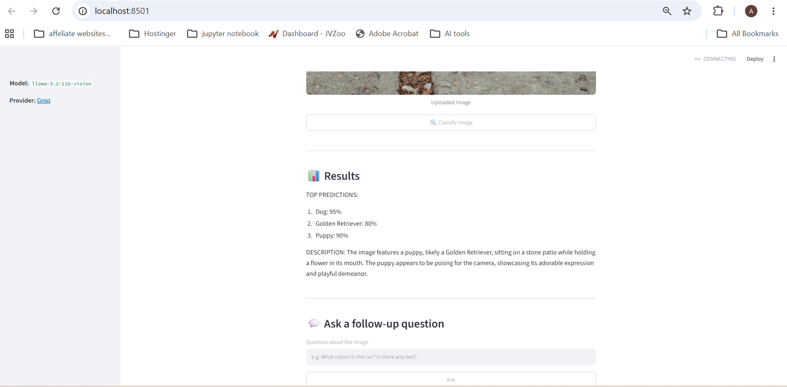

Docker desktop:
